**Analysing Product Sentiment (QUIZ:1)**

**1.Question:1**

The simple threshold classifier for sentiment analysis described in the video (check all that apply):

**Ans:1 Must either count attributes equally or pre-define weights on attributes.**

**2: Must have pre-defined positive and negative attributes.**

**2.Question:2**

### For a linear classifier classifying between “positive” and “negative” sentiment in a review x, Score(x) = 0 implies (check all that apply):

### Ans: We are uncertain whether the review is “positive” or “negative”.

**3.Question :3**

### For which of the following datasets would a **linear** classifier perform perfectly?

### Ans:

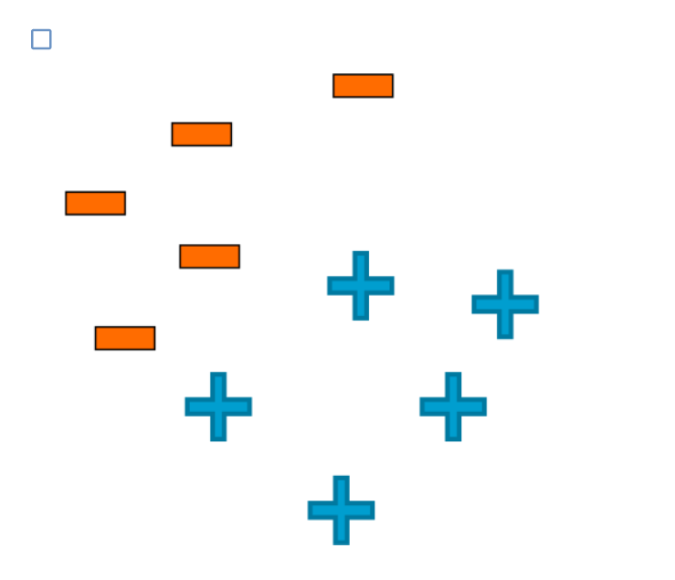

**4.Question:4**

### True or false:

### High classification accuracy always indicates a good classifier.

### Ans: False

**5.Question:5**

### True or false:

### For a classifier classifying between 5 classes, there always exists a classifier with accuracy greater than 0.18.

### Ans: True

**6.Question:6**

### True or false:

### A false negative is always worse than a false positive.

### Ans: False

**7.Question:7**

### Which of the following statements are true? (Check all that apply)

### Ans: test error tends to decrease with more training data until appoint, and then does not change(i.e., curve flattens out)